PRISM:

Provisioning Microsoft CSP perpetual and Software Subscription orders

Partners can now place orders for Microsoft CSP Perpetual and/or Software Subscription within PRISM.
Below are the process steps for ordering; however please be aware that all orders require upfront payment, invoices will be processed within 24 hours of an order being placed.
- Within PRISM, you will now have access to two new program tiles:
- Microsoft CSP Software Subscriptions
- Microsoft CSP Perpetual.
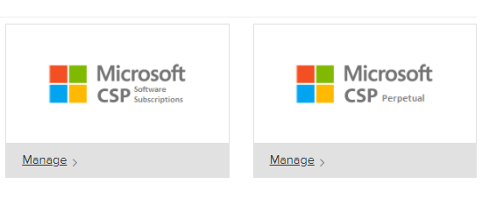

The below process will show the steps from the perspective of the Microsoft CSP Perpetual tile; however, the process is interchangeable with the Microsoft CSP Software Subscription Process.

Ordering Process:
Prerequisite: Be sure to have your customer’s active tenant created under the Microsoft CSP program tile with a status of ‘Normal’
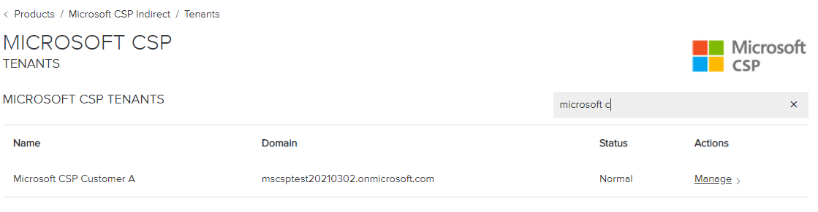

- Select ‘Manage’ under the Microsoft CSP Perpetual program tile
- Select ‘Create New Tenant’ under the Provision heading
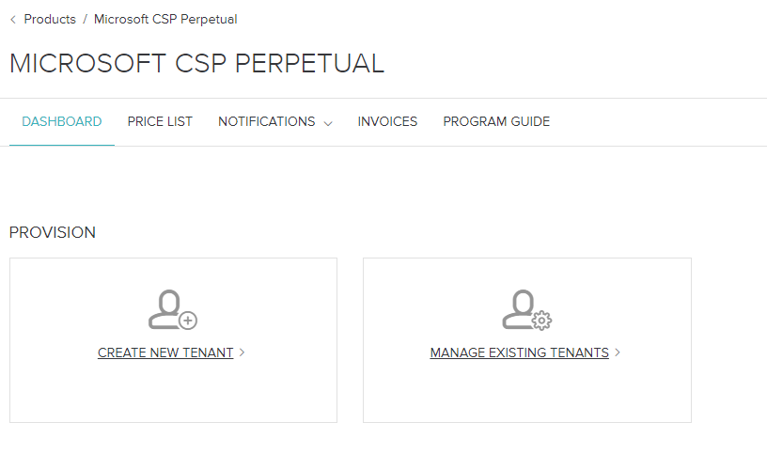
- Select ‘Use Existing PRISM Customer’ radio button, this step is important to marry the Perpetual and/or Software Subscription order to your Microsoft CSP tenant.
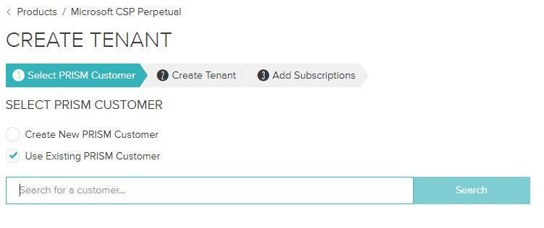

- Type the end customer’s name into the search bar and select ‘Search’
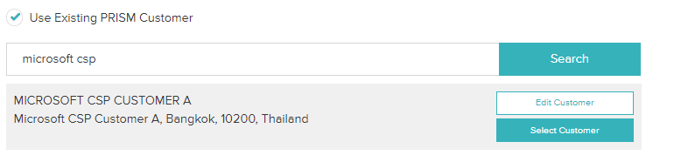
- Once you have the correct end customer select ‘Select Customer’
- Enter the End Customer Contact Details, including First Name, Last Name, Email Address and Phone Number
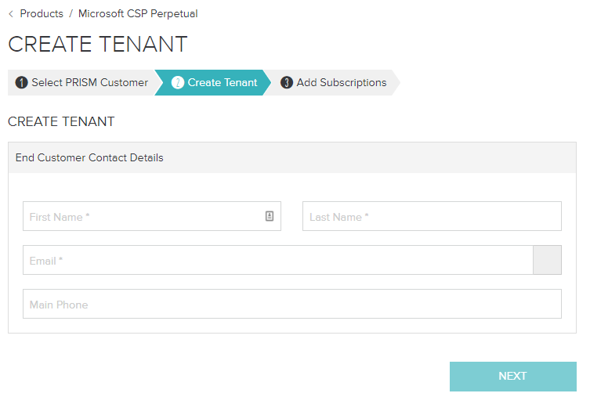

- Select ‘Next’

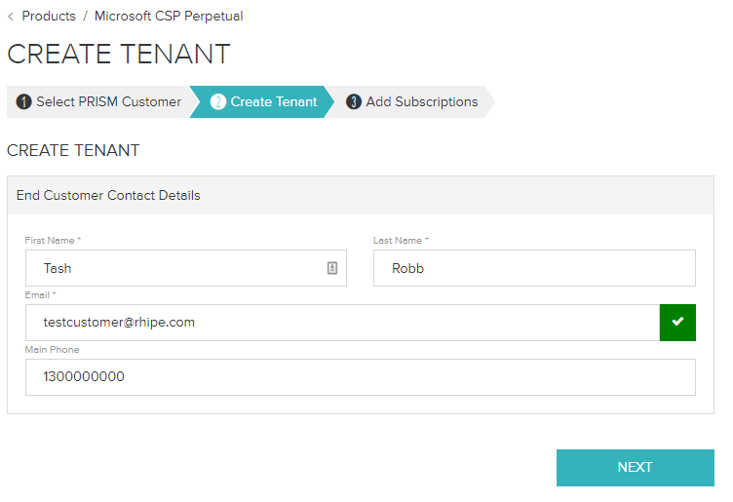
- Under the Add Subscriptions page, update the “How would you like to be billed for your subscriptions?” option to “Annually”
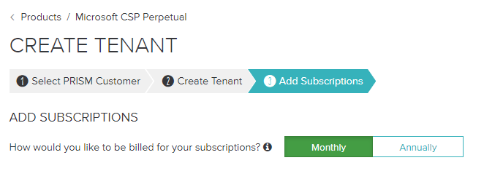
- Within this page you will be presented with various SKUs that can be ordered for your region, products can be searched using the ‘Filter Products’ search bar.
When selecting a SKU, please be mindful to ensure that the Region denoted on the SKU matches your End Customer’s Region and that the SKU Term matches the End Customer’s requirements. (Under Perpetual all SKUS are 12 months, under Software Subscriptions SKUs will have a 12- or 36-month option)
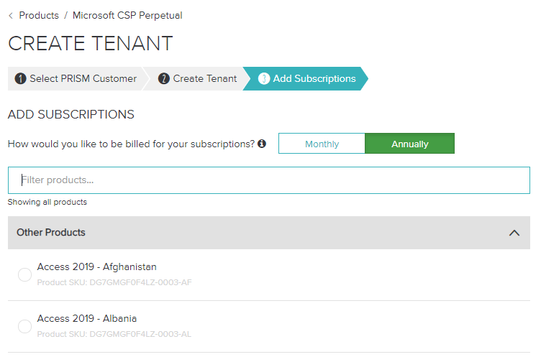
- Otherwise, you can scroll through the screen to locate the SKU that matches your requirements best.
- Once you have located the appropriate select the radio button against the SKU
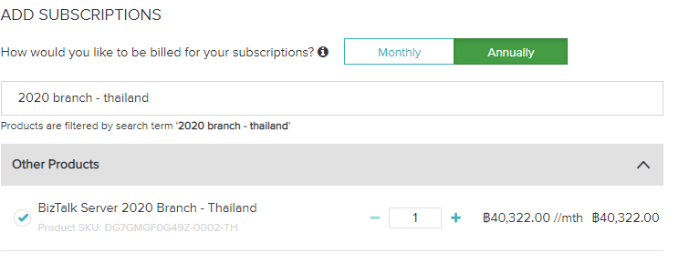
- Adjust the Quantity to match your requirements using the “+” and/or “-“ symbols.

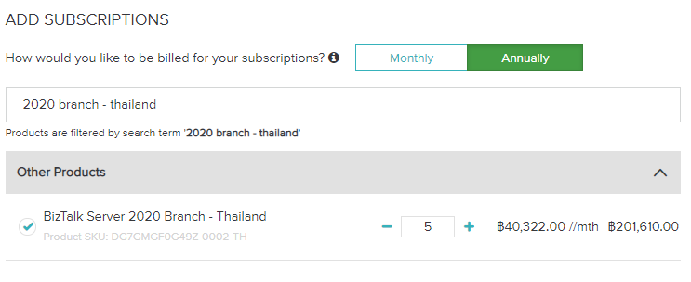

- Review the total values of your order under the Order Summary

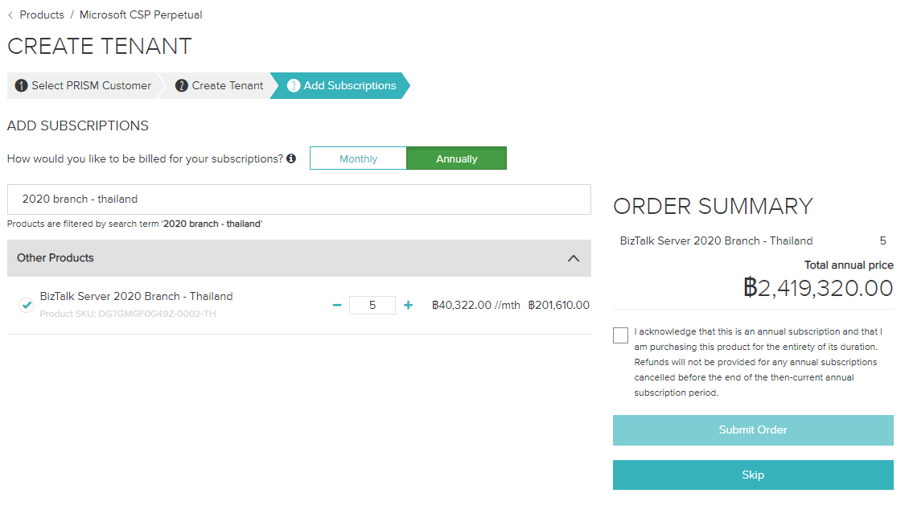
- Read the annual order acknowledgement under the Order Summary, and once understood, select the “I understand” icon
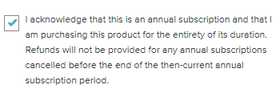
- Select ‘Submit Order’
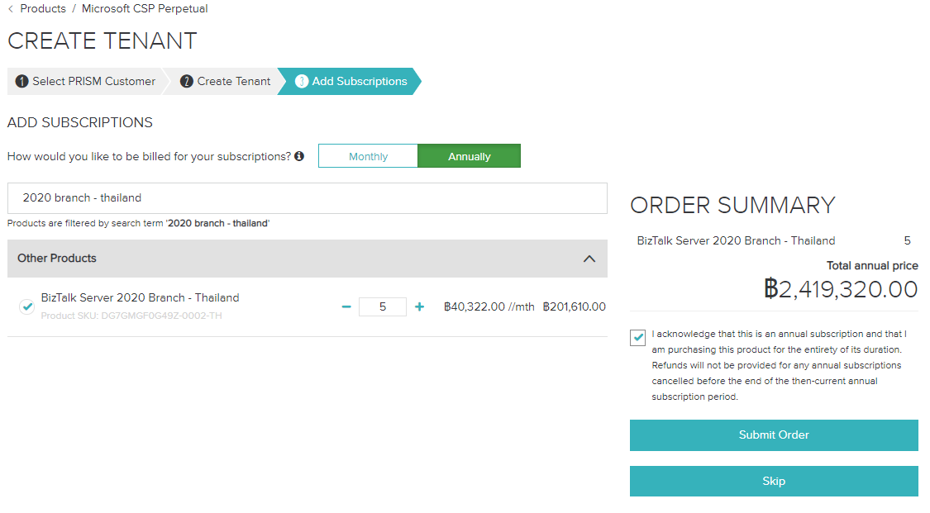
- Your order will then be processed by our rhipe Partner Support Team, who will send a notification once the order is fully provisioned. Please note that the notification will be sent from partner.support@rhipe.com.
- You will then receive an invoice within 24 hours of provisioning to match your order.

