PRISM Tenant User Guide:

Manage Users and Subscriptions

Create a tenant user

Overview
There are two types of user access levels in PRISM Partner Portal: a partner and a tenant. Both a partner and tenant are linked by a contract agreement. The dependency is depicted on the Figure 1.1.
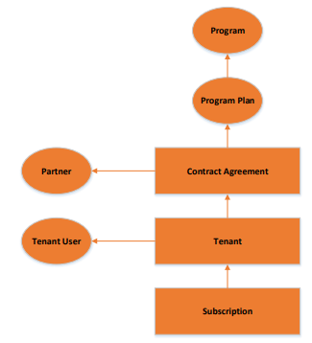
Figure 1.1.: PRISM Partner/Tenant Dependency Structure

  - Portal permissions and available functions are determined based on the level where a user is created.
  - For example:
- Users created at a partner level can access and perform the same functions as partners, i.e. access pricing, manage subscriptions of end-customers, sign-up to new programs, etc.
- Users created at a tenant level can access the same functions as tenants ie manage subscriptions at the tenant level, see retail pricing.
NOTE: Pricing is only displayed in ‘Add Subscription’ or ‘Manage Tenant’ page. This is applicable to consumption programs only.

Process for creating a tenant user
- Login to PRISM Partner Portal with partner credentials
Image 1.1: PRISM Login Page
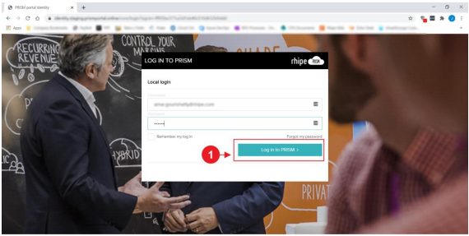
- Navigate to PRISM side menu and click on Customer Management
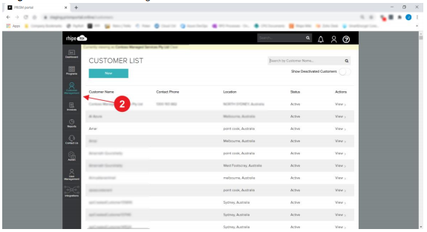
Image 1.2: PRISM Customer List Page

- Search for the customer record by typing the name in the search bar or by scrolling down the page
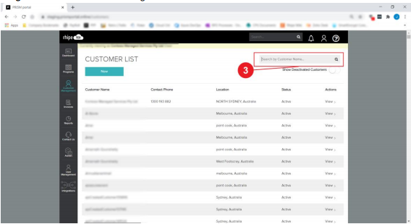
Image 1.3: PRISM Customer List Page

- Click on the name of the selected customer
NOTE: The customer name is a hyperlink which redirects to the Manage Customer Details Screen.

- Navigate to the Customer Administration area and click on Manage Users
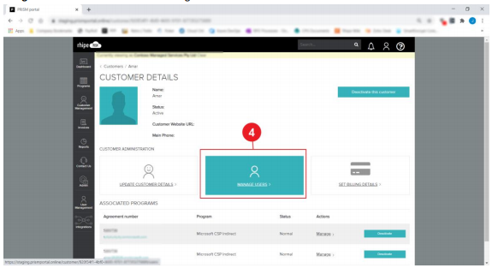
Image 1.4.: PRISM Customer Details Page

- Fill in user details and click on Create Customer button
NOTE: The Tenant User will receive an email with their login credentials
Image 1.5.: PRISM Manage Users Page
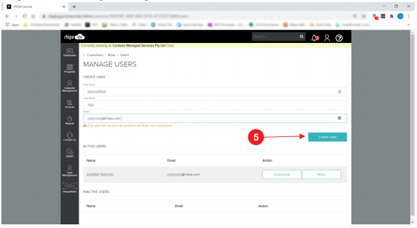

- A newly created user record is listed under the Active Users section. If you wish to reset a tenant user password, click on MORE
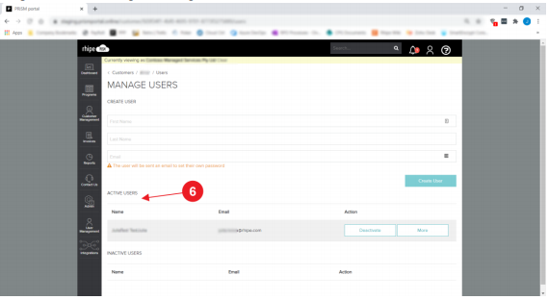
Image 1.6: PRISM Manage Users Page

  - Manage subscriptions by a tenant user
Below process illustrates how a tenant user can add or remove licences for an existing subscription as well as subscribe to a new subscription.

Process transcript
- Login to PRISM Partner Portal using tenant user credentials
- 2. Navigate to Programs in Use tile and click on View Details
Image 2.1: PRISM Partner Portal
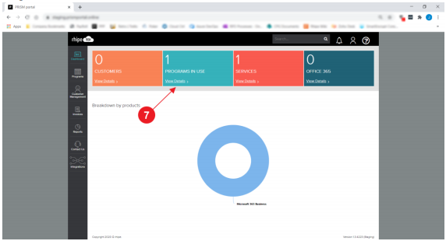

- Navigate to Active Signed Agreements section and click on Manage
Image 2.2.: PRISM Products and Programs Page
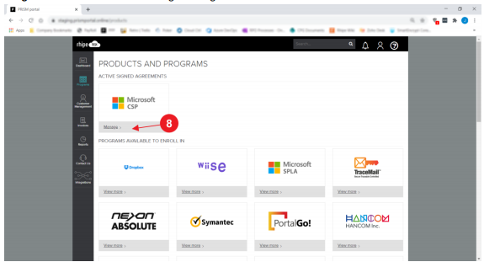

- Navigate to Tenants section and click on View Details
Image 2.3: PRISM Dashboard Page
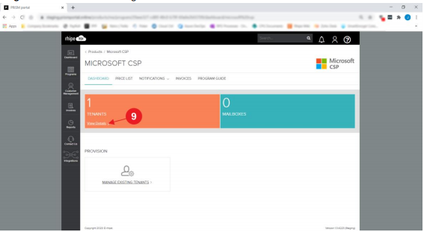

- Click on Manage next to the chosen tenant record
Image 2.4: PRISM Tenants List
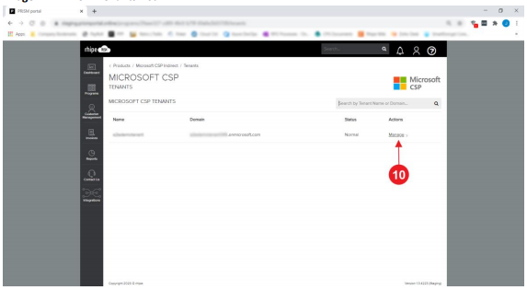
- To make changes to the existing subscription, click on Manage under the Active Subscription section
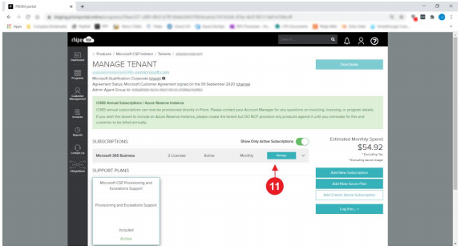
Image 2.5: PRISM Manage Tenant Page

- Click on ‘+’ or ‘-‘ to add or remove licences in the subscription;
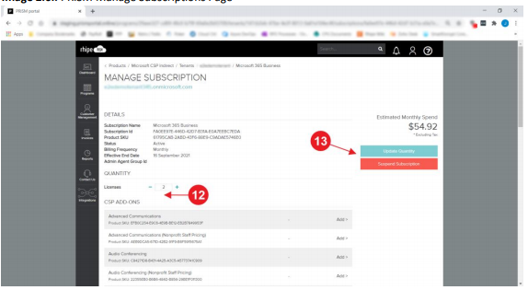
- Click on Update Quantity button to apply changes to the existing active subscription; NOTE: A user can suspend the subscription by clicking on Suspend Subscription button. Image 2.6.: PRISM Manage Subscriptions Page

- To add a new subscription, click on Add New Subscription
Image 2.7.: PRISM Manage Subscriptions Page
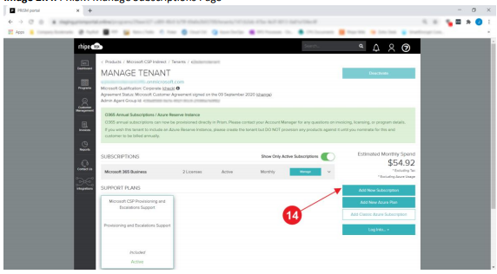

- Use ‘+’ or ‘-‘ to add or remove number of licences;
- Click on Submit Order to save the selection;
Image 2.8.: PRISM Add Subscriptions Page
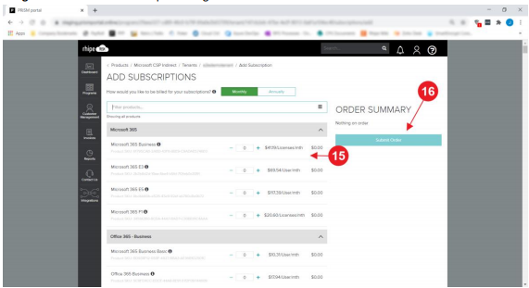

Deactivate a tenant user
  - Below process illustrates how a partner can remove access from a tenant user in PRISM Portal. NOTE: By deactivating a tenant user, a partner removes the access to PRISM Partner Portal from the tenant user. A tenant user can deactivate other users against the same tenant.

Process of deactivating a tenant user
- Login to PRISM Partner Portal with partner credentials
- Navigate to PRISM side menu and click on Customer Management
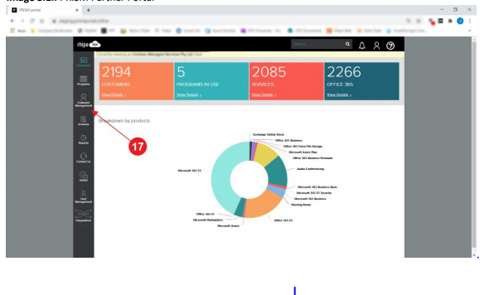
Image 3.1.: PRISM Partner Portal

- Click on the name of the selected customer; NOTE: The customer name is a hyperlink which redirects to the Manage Customer Details Screen. Image 3.2.: PRISM Customer List Page
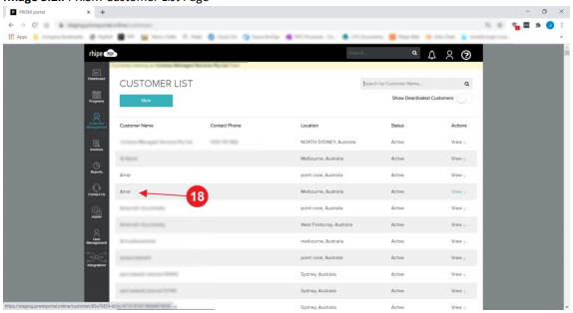

- Navigate to the Customer Administration area and click on Manage Users
- Choose a user for the deactivation and click on Deactivate button
NOTE: By deactivating a tenant user, a partner removes the access to PRISM Partner Portal from the tenant user.

Image 3.3: PRISM Manage Users Page.

